Ofono, DBus and D-feed

Ofono
Install ofono-phonesim. To avoid starting ofono-phonesim each time when starting the operating system, add the following line
ofono-phonesim -p 12345 -gui /home/christoph/angstrom/default.xml
(adjust it to meet your system specific needs) to your startup applications.
>> System / Preferences / Startup Applications
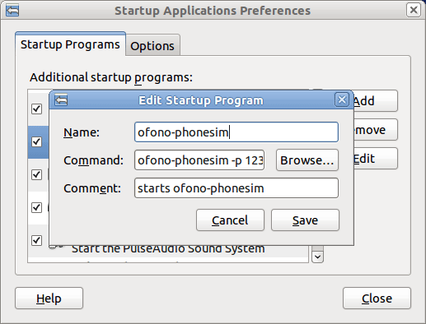
Enter
dbus-send --print-reply --system --dest=org.ofono /phonesim org.ofono.Modem.SetProperty string:"Powered" variant:boolean:"true" to test ofono and to turn the modem on.
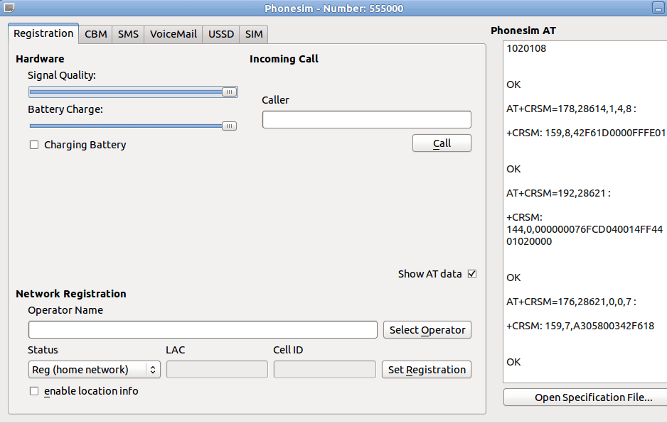
Dial a number
dbus-send --print-reply --system --dest=org.ofono /phonesim org.ofono.VoiceCallManager.Dial string:"012345" string:"default"

D-feed
Install d-feet the D-Bus debugger and create a System Bus to check the org.fono connection:
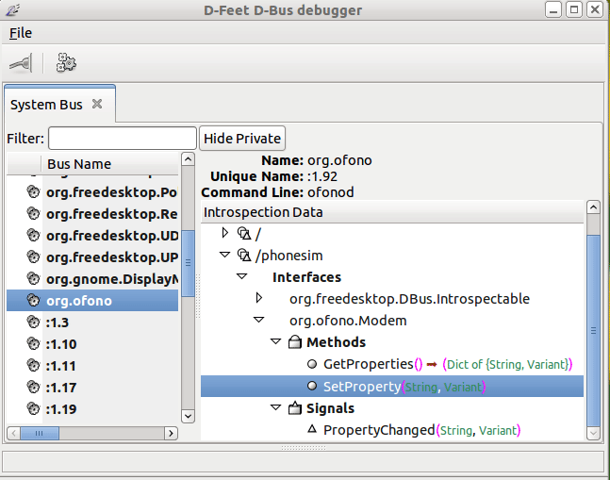

Additional Ofono commands
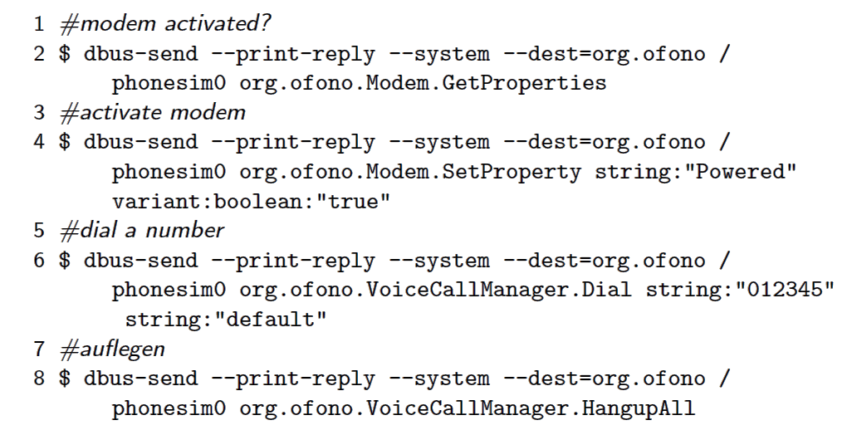

Create CPP files out of the XML files
See Group-Project.pdf page 14 and following.

1.) Power up the “phone”:
sudo dbus-send --print-reply --system --dest=org.ofono /phonesim org.ofono.Modem.SetProperty string:"Powered" variant:boolean:"true"

2.) Enter:
dbus-send --print-reply --system --dest=org.ofono /phonesim org.freedesktop.DBus.Introspectable.Introspect > ofono.xml
Open the generated ofono.xml and remove some debug information at the beginning and end of the file. Match unknown types to the appropriate Qt types. The method argument a{sv} is unknown so we add an annotation how to match this to a Qt type.
3.) Create proxy classes:
1 qdbusxml2cpp -p OfonoModem ofono.xml org.ofono.Modem
2 qdbusxml2cpp -p OfonoSimManager ofono.xml org.ofono.SimManager
3 qdbusxml2cpp -p OfonoVoiceCallManager ofono.xml org.ofono.VoiceCallManager

